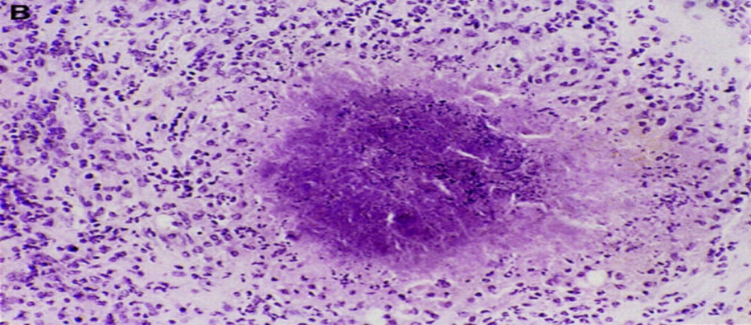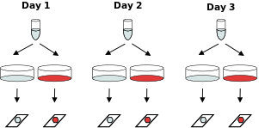

Original *B. pertussis*

Six total samples

Two technical replicates of each with dye-swap

3 biological replicates from original *B. pertussis Strain*